Jimmy Tran
Bourgeois
CSC 4222
8 November 2017
Programming Assignment 3
1. I had two IP addresses: 104.193.88.77 and 104.193.88.123. The first seems to belong to baidu.com while the second belongs to its alias: www.a.shifen.com
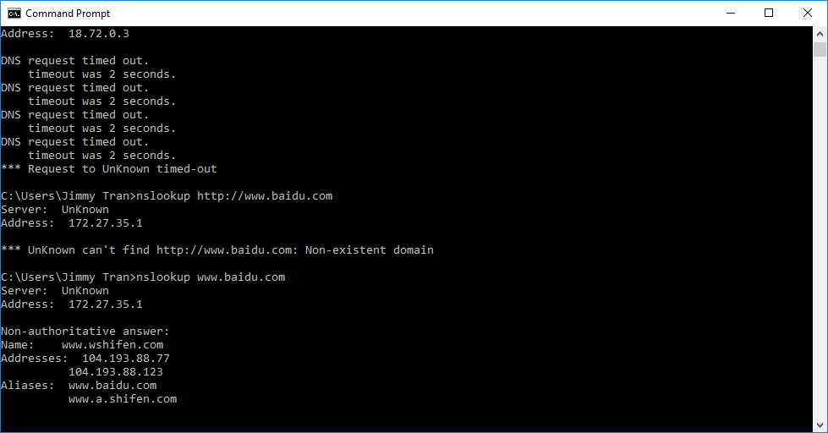
2. The University of Berlin seems to use 5 authoritative name servers one of which is actually American, atalante.stanford.edu with IP address 171.64.7.61
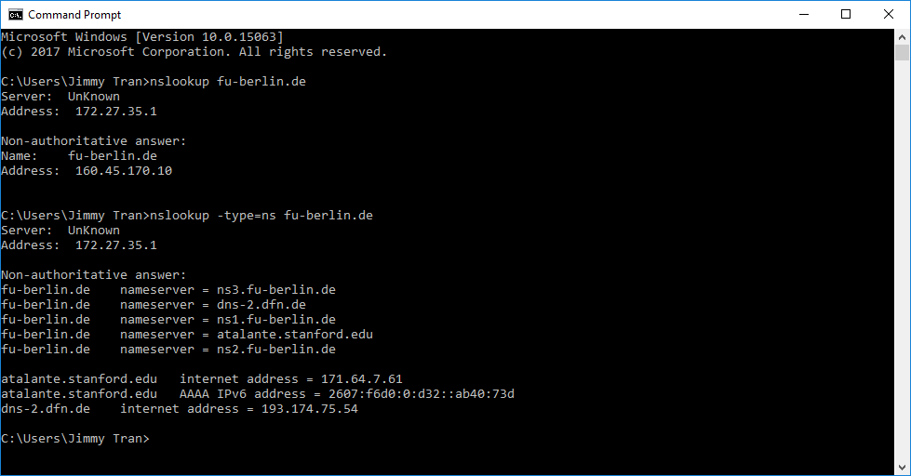
3. The query is refused for whatever reason. Perhaps it fails only on Windows? I heard it does work on Mac and Linux.
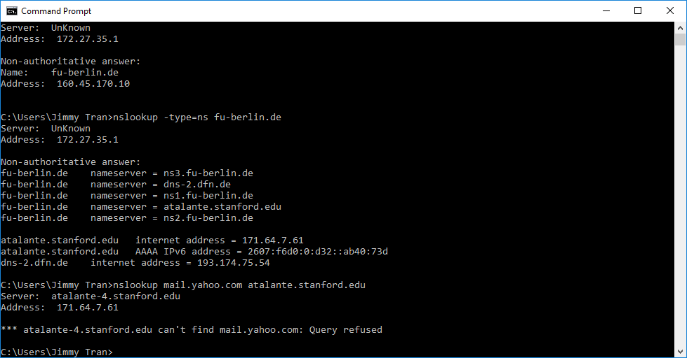
4. The query is sent to 172.27.35.1. This is indeed my default DNS server.
5. Screenshot below:
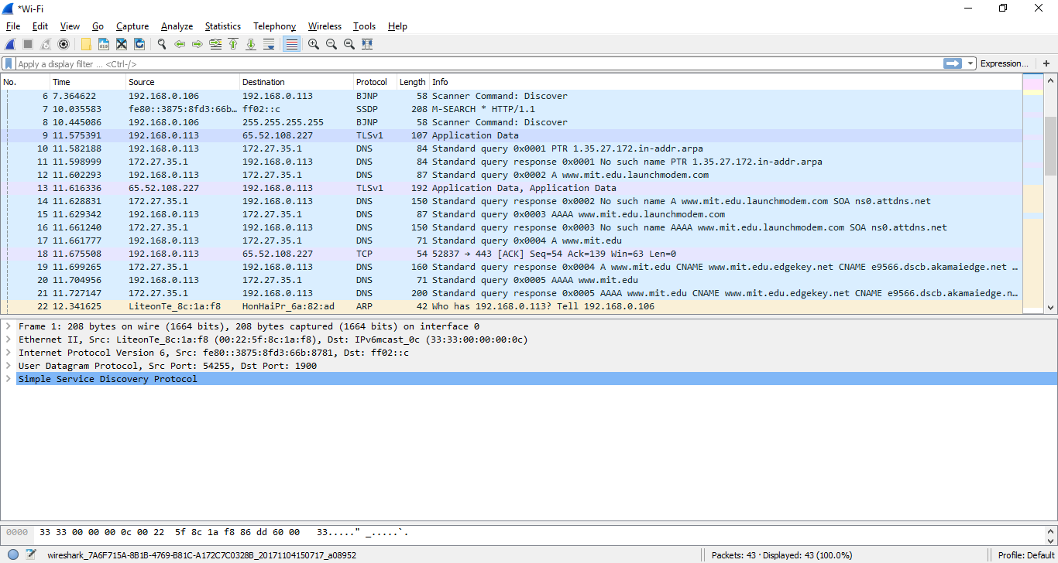

PingPlotter screenshots at packet sizes 56, 2000, and 3500 in that order for questions 6-9:
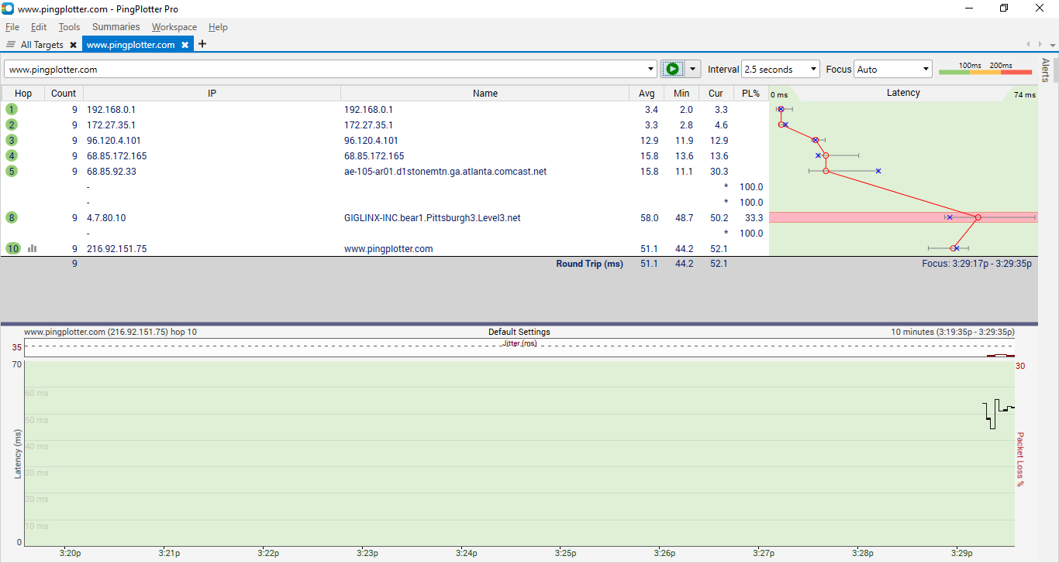
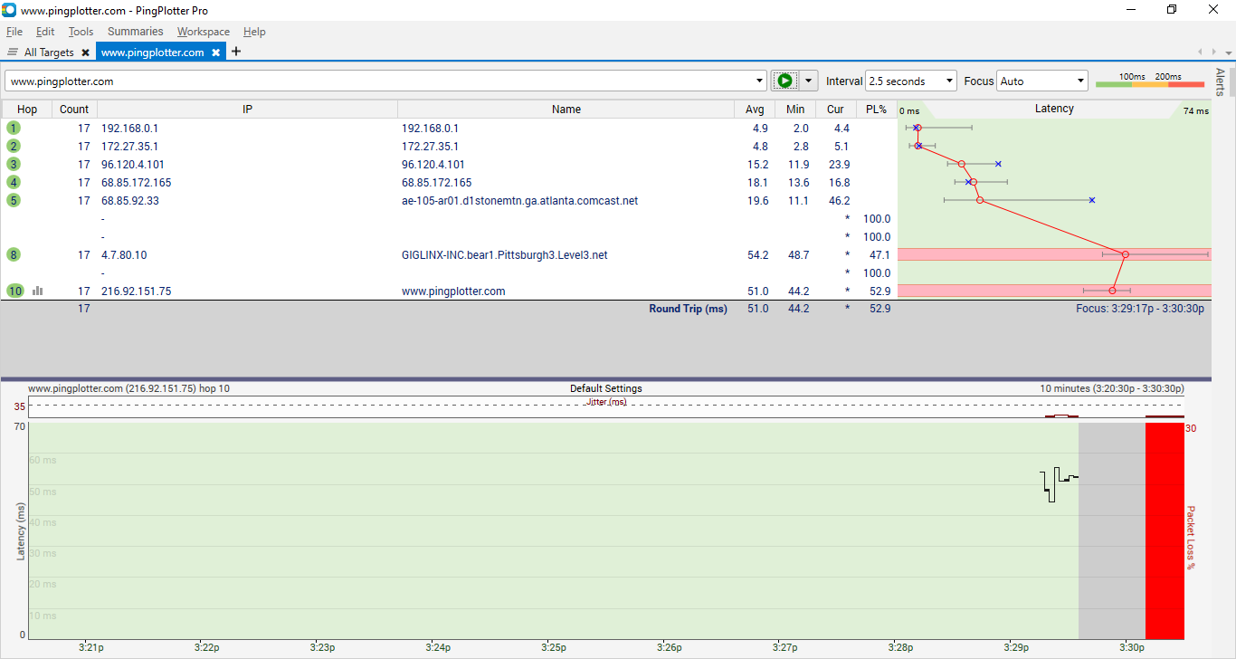
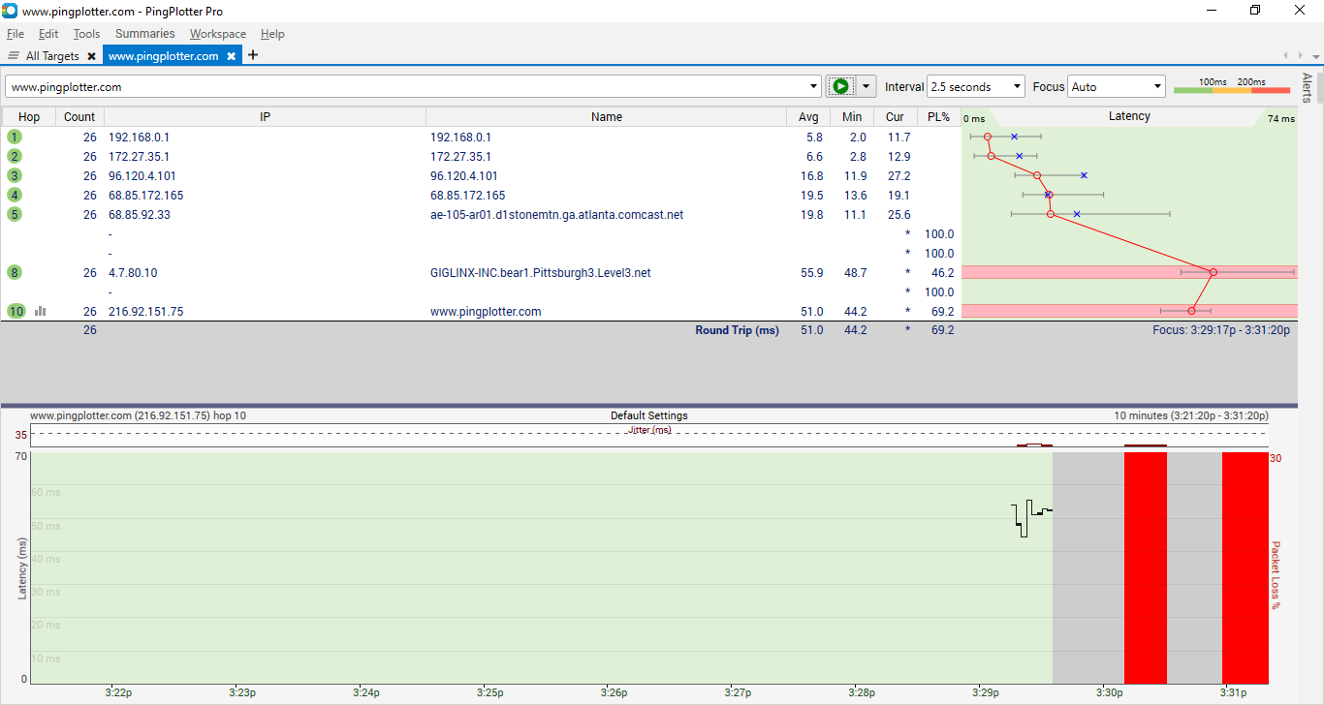

6. My computer’s IP address is 192.168.0.113.
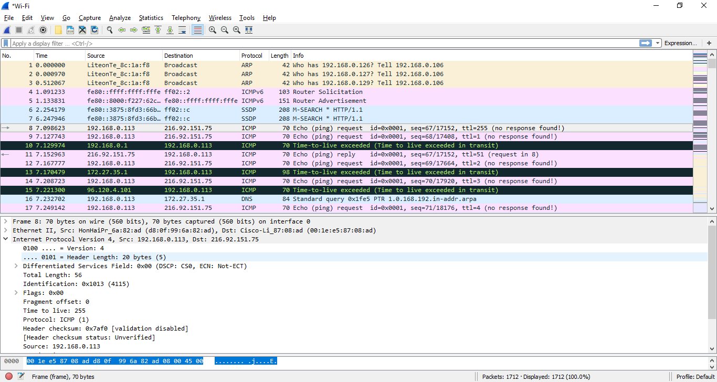
7. Not entirely sure what this is asking, but if it’s the first line of the IP packet that is being referred to, the value is 0100 (or 4) meaning version 4 of the Internet Protocol.
8. 20 bytes are in the IP header. The payload is 36 bytes are that is the difference of the total length and header size or 56-20=36.
9. It is fragmented as the length in the upper window is 70 and the total bytes of the packet is listed in the lower window as 560.

